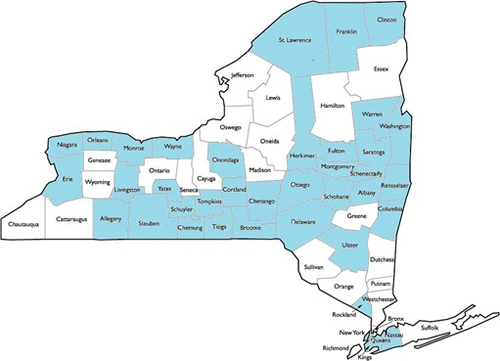  Check out our map of REST coverage!  The blue counties on this map are locations across the state where NYSCRC has trainer coverage for REST! Help us to keep our ground and make some more progress.  Mon April 16 at 3PM  Monthly NYSCRC REST Trainer Call  1-585-287-6350 code 483# at both prompts  - Enter your companion monthly hours to NYSCRC! Click here to go to the link! (Link will be live on the NYSCRC website soon)  - Wondering what to plan for May, Older Americans Month and the 2018 theme, Engage at Every Age.? How about a REST training?  - Want to be a Powerful Tools for Caregivers leader? We can help with that. Let us know if you are interested.  - Need a speaker for a caregiver event? Doris is continually asked to speak and will be glad to come to your program or conference.  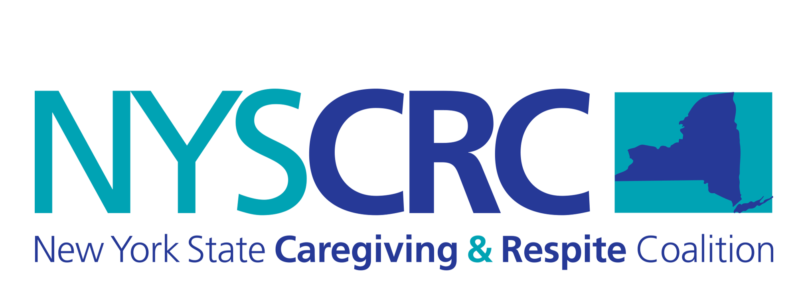  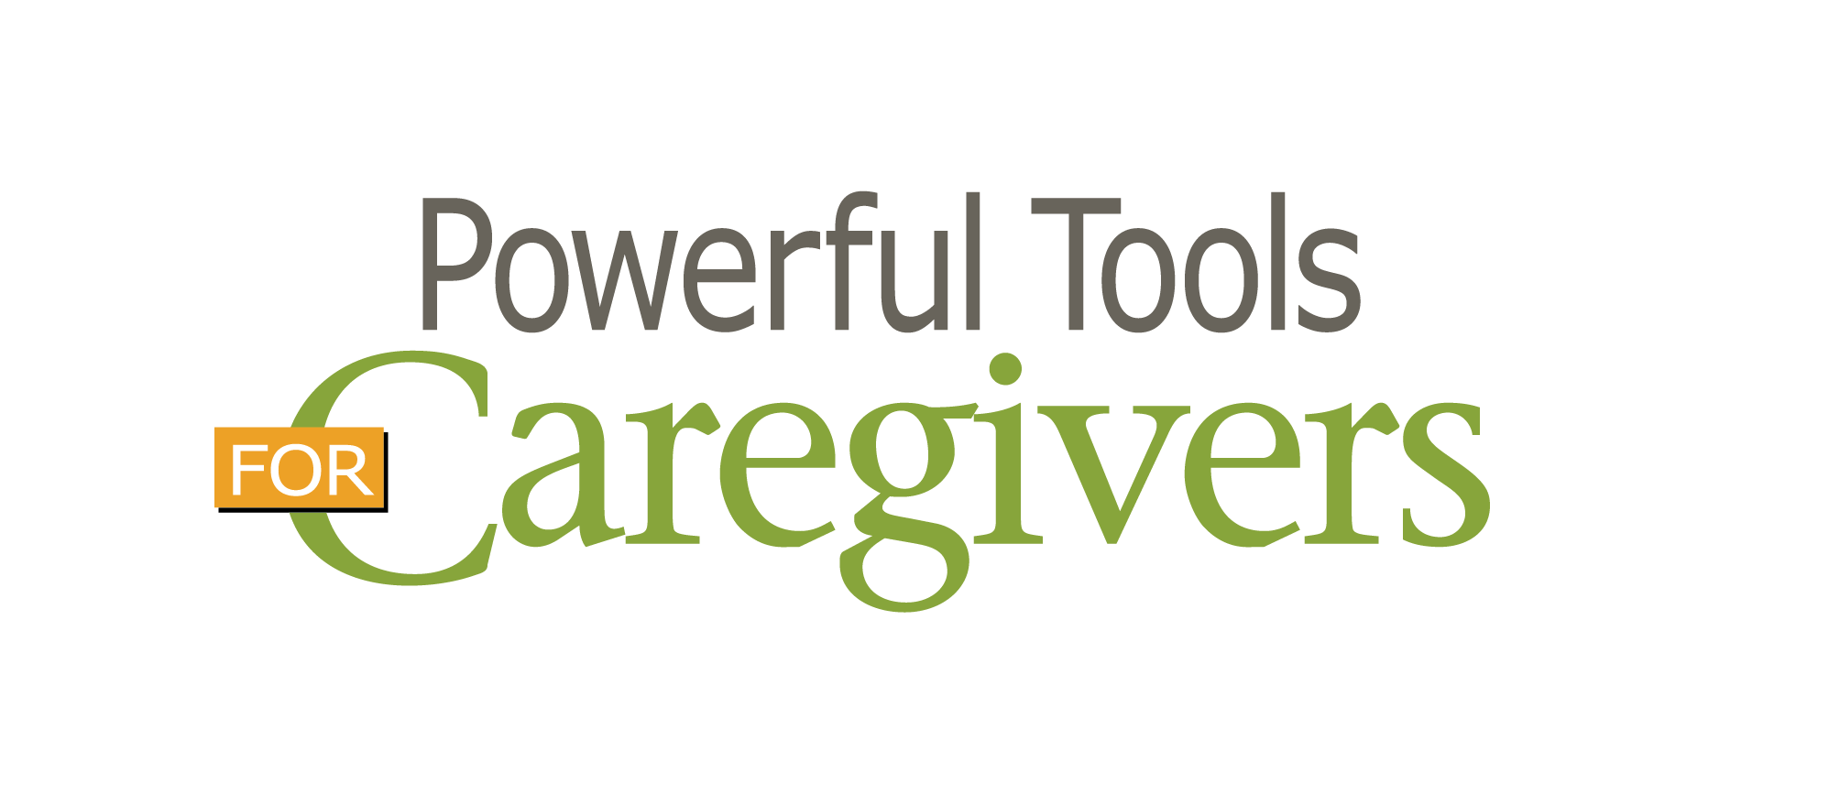 | Need companion guides?  Contact Doris  ────  REST  Train theTrainer coming to Warsaw May 31 & June 1  ────  Caregiver Simulation hosted by Chemung Co June 15  ────  Click here to like & follow the NYSCRC Facebook Page! ────  Click here to join the NYSCRC REST Trainer Facebook group!  Questions or comments?  dgreen@lifespan-roch.org  Telephone  Web Address

